By default open gl restricts our coordinates to normalized coordinates

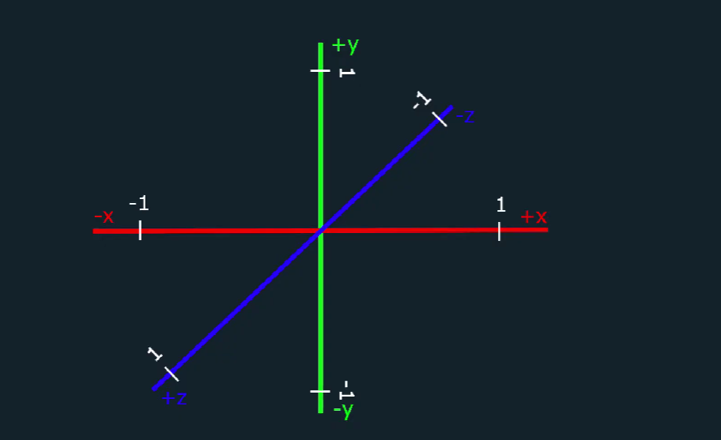

So to expand our coordinates we use the matrices